**Assignment-1**

Connect and disconnect with login Access

* What happens when you login a non-existent users or username?
  + Provide Screenshot and What you understand, explain in short brief?

Solution:

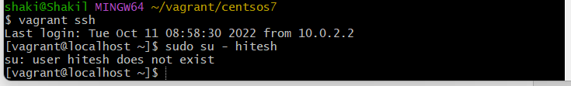

Whenever I’m trying to switch/login with user hitesh. I get error as user hitesh does not exist. It means that user " hitesh” is not created/available in the linux system. We only have 2 login users as of now in the system as shown below.



**Assignment-2**

Password changing

* Login into your account and then change password?
  + Change your password into **IneuR0n#42** and hit the **Enter** key
    - Explain what happen and give screenshot?

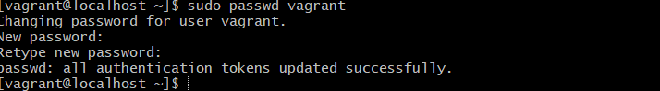

* Changed password successfully into **IneuR0n#42.**
* Try again to change password but use like password ***1234*** or ***abcd***
  + - Explain what happen and give screenshot?

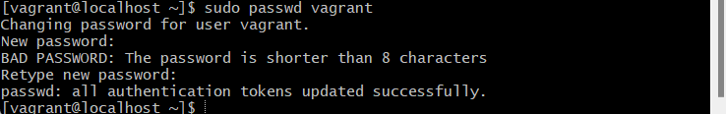

* Here password changed successfully, but we got warning as bad password (weak password)
  + Try again to change password but now don’t use any password just hit **Enter** key
    - Explain what happen and give screenshot?

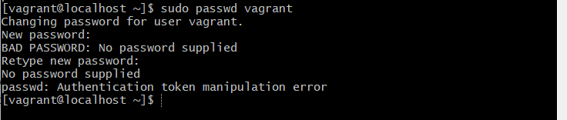

* + Tried again to change password but now didn’t use any password just hit **Enter** key, I throw an error as “no password supplied”.

**Assignment-3**

Working with Directories

* Enter the command **cd /** and then **ls** and then hit **Enter** key
  + Take screenshot and explain what output we got?

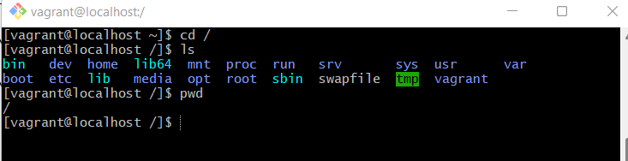

* Cd / commands will bring it to root directory, is a topmost directory in the Linux system. Upon list “ ls” it will list all the files, devices data and system information in this directory.
* Enter the command now **cd /home** and then hit **Enter** key
  + Do **ls,** provide screenshot and explain what is **/home** directory used for?

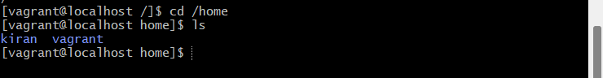

* Cd /home directory is for particular user of the system and consists of individual files. Also, known as login directory.
* Enter **cd ..** and hit **Enter** key [ *Note: here we have space after cd then use double dot*]
  + Check what happen and give screenshot?

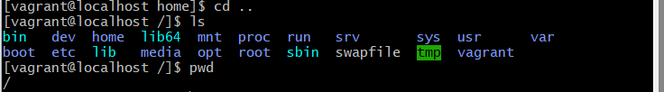

* Terminal will bring back to root directory.
* Now enter **cd /var/www/html** and then type **cd** and hit **Enter** key
  + Explain what happen and give screenshot?

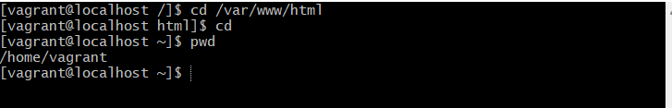

If we enter the command enter cd /var/www/html, then we are in the html folder ( if www/html already exists). /var provides logs of a system.

Enter cd, prompt will back to user’s home directory

* Now type **cd /root** and then hit **Enter** key
  + Do **ls,** check any output we have on screen if yes then take screenshot?



This user does not required permission to execute the /root directory. /root is root user home directory.

**Assignment-4**

Working with File Listing

* Go to **cd /etc** and type **ls**
  + Take screenshot and explain what files you have seeing?
  + Take screenshot and explain what different output you found compare to previous command you used?
* 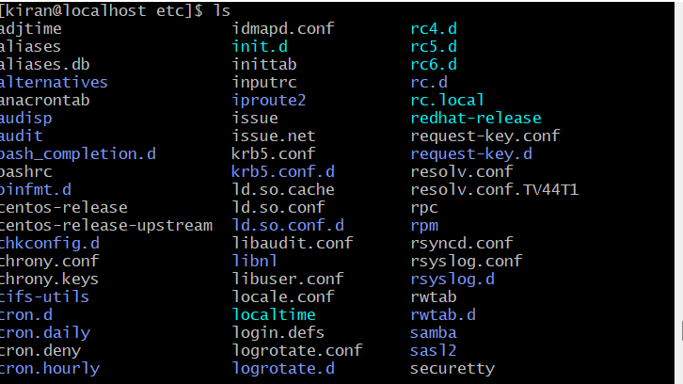
* /etc directory contains all the system configuration files such as user details, system info, any other software installation etc.
* Then type **ls -al** and hit **Enter** key
  + Take screenshot and explain what new file or directory you found?
* 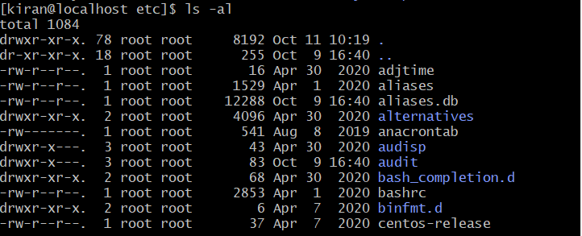
* It will list all the files in “ALPABETICAL ORDER” along with their permissions. It also list the hidden files ( . . files)
* Then use **ls -i** and hit **Enter** key
  + Now see what different output its shows and take screenshot?

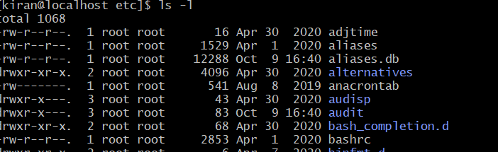

It does the same line ls -al but does not display hidden files.

* Then use **ls –help** and see other options about **ls** command
  + Explore it and try with other attribute we can use with **ls** command

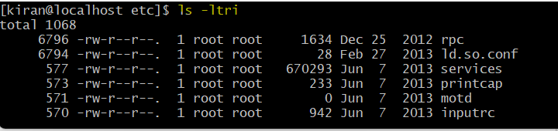

It displays the al the files, directories, and links with their permissions in reverse order (latest in bottom). Also, display the inode number.

**Assignment-5**

Know where you are and where you working

*Here we use* ***pwd, cd and ls*** *as combine task to understand where you working on terminal and how you can switch from one directory to another one.*

* Open terminal after restart the linux
  + Check which location you working, type **pwd** and take screenshot
* Now use **cd /var** and hit **Enter** key
  + Do **ls,** and see what output comes, give screenshot?
* Do explore other help options of each command to learn more other things we can do with these commands

Pwd – will print the current/present working directory

cd- will change the directory from current to next/previous directory.

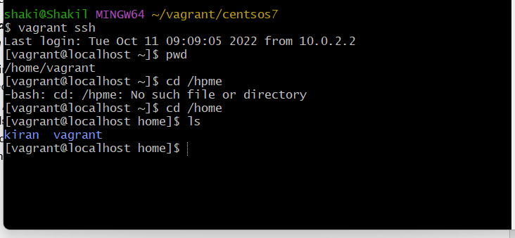

Cd /var - it will enter into /var directory ls -will list all the files and directory within /var directory.

